- To Create Process Escape Sequences, Handle Escaped Spaces, Escape Special Symbols, Preserve Characters, Validate Parser Output, Test Complex Inputs.
Code: #include <stdio.h>
#include <string.h>
#include <ctype.h>

void parse_command(char *input) {
char output[200];
int i = 0, j = 0;
int escaped = 0;

while (input[i] != '\0') {
if (escaped) {
output[j++] = input[i];
escaped = 0;
}
else if (input[i] == '\\') {
escaped = 1;
}
else {
output[j++] = input[i];
}
i++;
}

output[j] = '\0';

printf("Parsed Output: %s\n", output);
}

int main() {
char input[200];

printf("Enter command: ");
fgets(input, sizeof(input), stdin);

input[strcspn(input, "\n")] = '\0';

printf("\nOriginal Input: %s\n", input);

parse_command(input);

printf("Parser validation completed.\n");

return 0;
}
output:
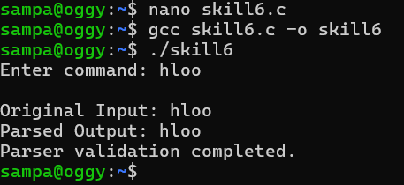
To Create Child Processes, Execute Programs, Handle Execution Errors, Pass Arguments, Manage Parent Process, Test Command Launching.
code: #include <stdio.h>
#include <stdlib.h>
#include <unistd.h>
#include <sys/wait.h>

int main() {
pid_t pid;

printf("Parent process started.\n");

pid = fork();

if (pid < 0) {
perror("fork failed");
return 1;
}

if (pid == 0) {
printf("Child process created.\n");
printf("Child PID: %d\n", getpid());

char *args[] = {"ls", "-l", NULL};

printf("Executing ls -l...\n");

execvp(args[0], args);

perror("Execution failed");
exit(1);
}
else {
printf("Parent waiting for child...\n");

wait(NULL);

printf("Child process completed.\n");
printf("Parent process completed.\n");
}

return 0;
}
output:
